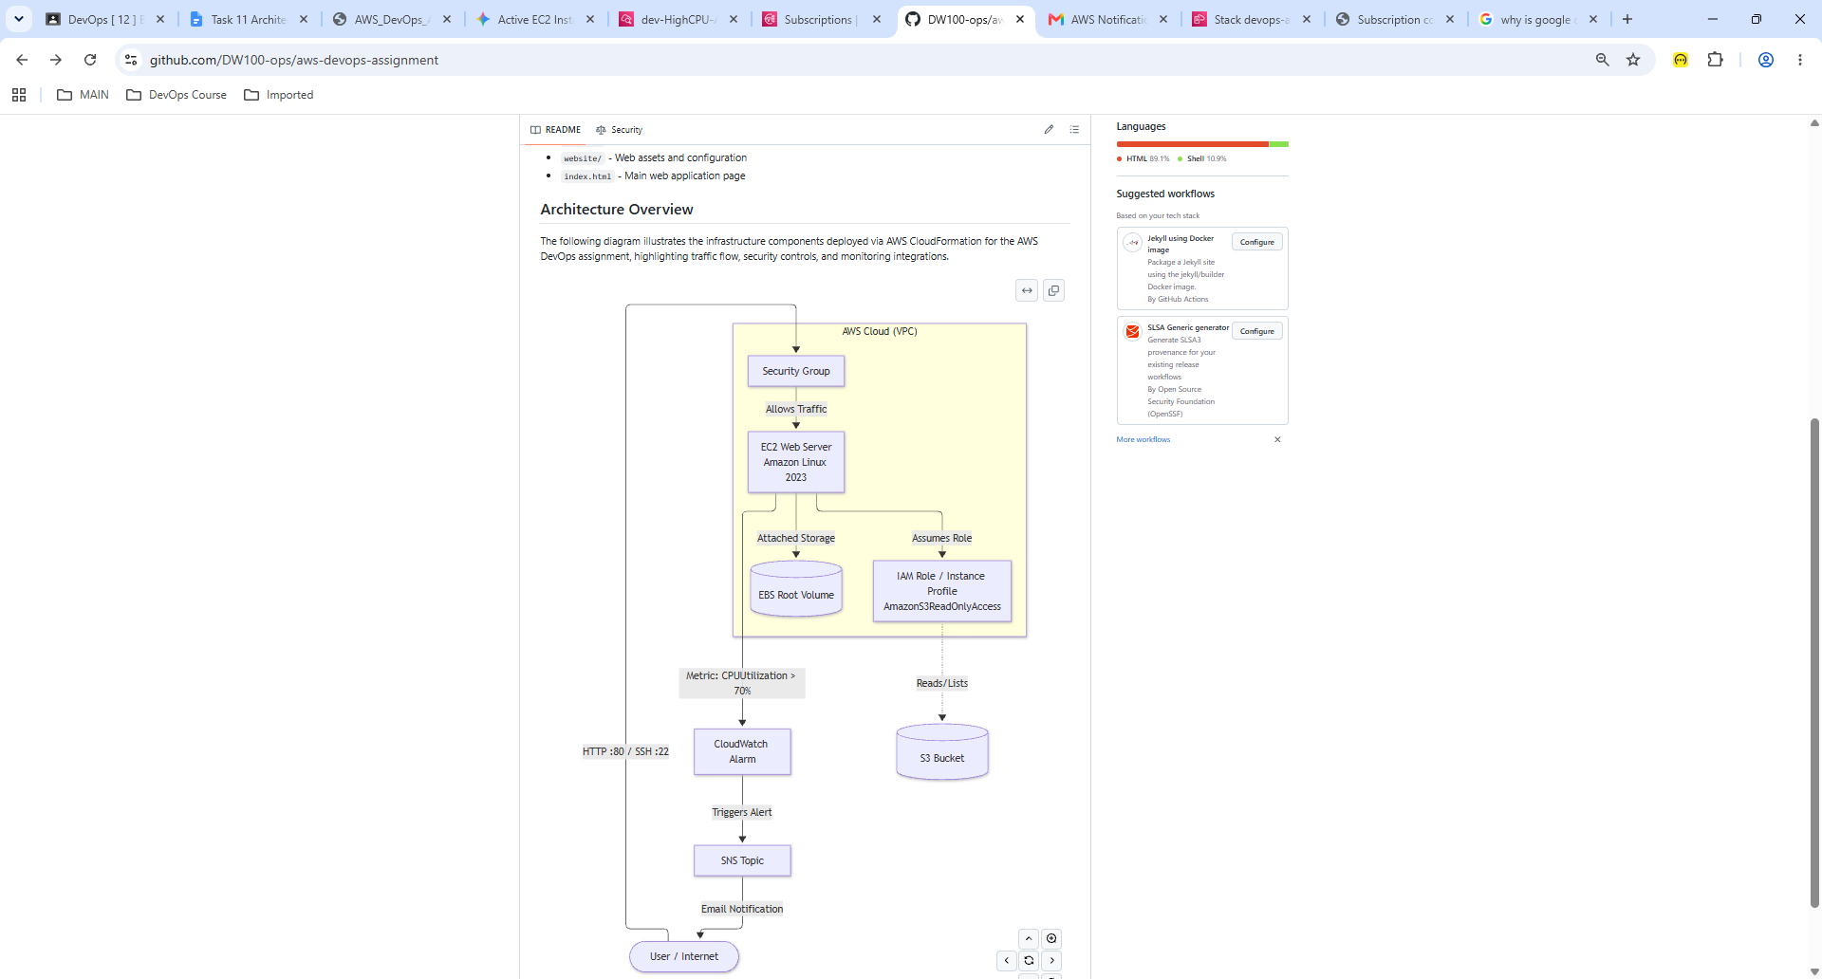

Component Breakdown & Data Flow:
- Internet / User: Originates public HTTP requests to the web server and receives email notifications.
- Security Group (WebServerSecurityGroup): Acts as a virtual firewall controlling inbound traffic on Port 80 (HTTP) and Port 22 (SSH).
- EC2 Web Server (WebServerInstance): Hosts the Apache web server application serving the assignment index page.
- EBS Volume: Provides persistent block storage for the EC2 operating system and file system.
- IAM Role & Instance Profile (WebServerRole): Grants secure, credentials-free read access to AWS services (specifically S3).
- S3 Bucket (MyS3Bucket): CloudFormation-managed object storage bucket with versioning enabled.
- CloudWatch Alarm (CPUUtilizationAlarm): Continuously monitors EC2 CPU metrics and breaches if usage exceeds 70% over a 5-minute evaluation period.
- SNS Topic (AlarmTopic): Broadcasts alarm events to subscribed administrative endpoints (email).

Save the file (`Ctrl + S`), and you're good to go!

